**Date: / /2020**

**Practical no 7**

**AIM**: **:** Define a web service method that returns the contents of a database in a JSON string. The contents should be displayed in a tabular format.

**Steps for creating a Database:**

**1]** Open Microsoft SQL Server Management Studio. After opening the Management Studio it will ask to connect to a server. Select a proper server and click connect.

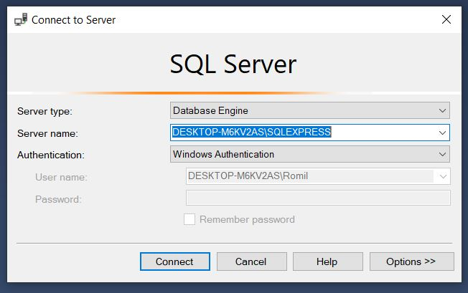

**2]** From object explorer right click on **Databases** and click **New Database.** Give name to Database.

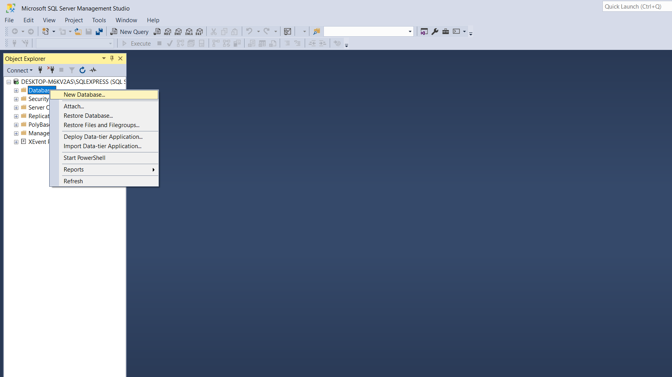

3] Right Click on **Tables** and select **New ->Table**.

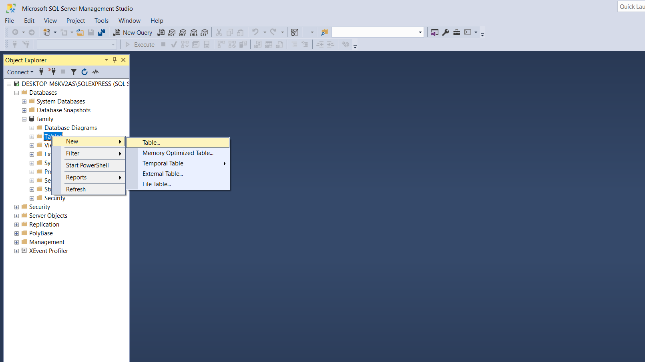

**4]** Edit column name and datatypes.

**5]** Save the table and give a name.

**6]** From **Tables** select the table you created. Right click on it and select **Edit top 200 rows.**

**7]** Enter the data into the table and save.

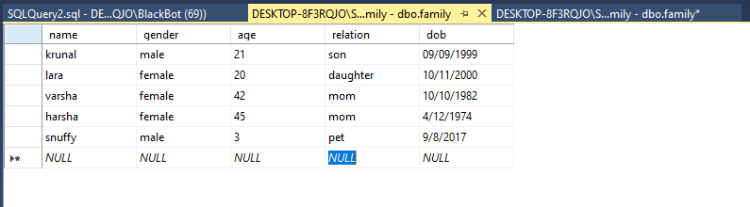

**CODE:-**

**Family.cs:**

|  |
| --- |
| using System;  using System.Collections.Generic;  using System.Linq;  using System.Web;  namespace prac7  {  public class Family  {  public string name { get; set; }  public string gender { get; set; }  public string age { get; set; }  public string relation { get; set; }  public string dob { get; set; }  }  } |

**Webservice.asmx.cs:**

|  |
| --- |
| using System;  using System.Collections.Generic;  using System.Configuration;  using System.Data.SqlClient;  using System.Linq;  using System.Web;  using System.Web.Script.Serialization;  using System.Web.Services;  namespace prac7  {  /// <summary>  /// Summary description for WebService1  /// </summary>  [WebService(Namespace = "http://tempuri.org/")]  [WebServiceBinding(ConformsTo = WsiProfiles.BasicProfile1_1)]  [System.ComponentModel.ToolboxItem(false)]  public class WebService1 : System.Web.Services.WebService  {  [WebMethod]  public string JsonData()  {  List<Family> objFamilylist = new List<Family>();  string str = ConfigurationManager.ConnectionStrings["DBContext"].ConnectionString;  using (SqlConnection con = new SqlConnection(str))  {  SqlCommand cmd = new SqlCommand("select * from family", con);  cmd.Connection = con;  con.Open();  SqlDataReader rdr = cmd.ExecuteReader();  while (rdr.Read())  {  Family family = new Family();  family.name = rdr["Name"].ToString();  family.gender = rdr["Gender"].ToString();  family.age = rdr["Age"].ToString();  family.relation = rdr["Relation"].ToString();  family.dob = rdr["Dob"].ToString();  objFamilylist.Add(family);  }  JavaScriptSerializer js = new JavaScriptSerializer(); return js.Serialize(objFamilylist);  }  }  }  } |

**Web.config**:-

|  |
| --- |
| <?xml version="1.0" encoding="utf-8"?>  <!--  For more information on how to configure your ASP.NET application, please visit  https://go.microsoft.com/fwlink/?LinkId=169433  -->  <configuration>  <system.web>  <compilation debug="true" targetFramework="4.7.1"/>  <httpRuntime targetFramework="4.7.1"/>  </system.web>  <connectionStrings>  <add name="DBContext" providerName="System.Data.SqlClient" connectionString="Data Source=DESKTOP-8F3RQJO\SQLEXPRESS01;Initial Catalog=family;Integrated Security=True "/>  </connectionStrings>  <system.serviceModel>  <bindings>  <basicHttpBinding>  <binding name="WebService1Soap" />  </basicHttpBinding>  </bindings>  <client>  <endpoint address="http://localhost:58555/WebService1.asmx"  binding="basicHttpBinding"  bindingConfiguration="WebService1Soap"  contract="ServiceReference1.WebService1Soap"  name="WebService1Soap" />  </client>  </system.serviceModel>  </configuration> |

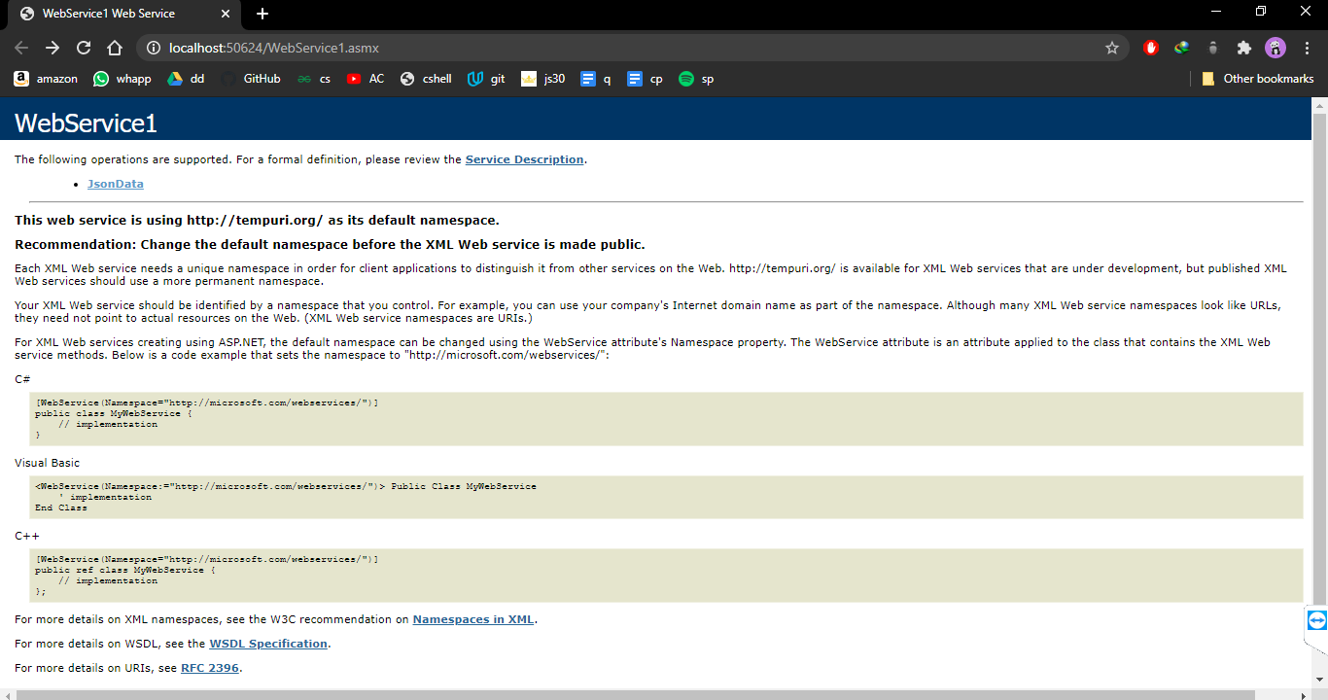

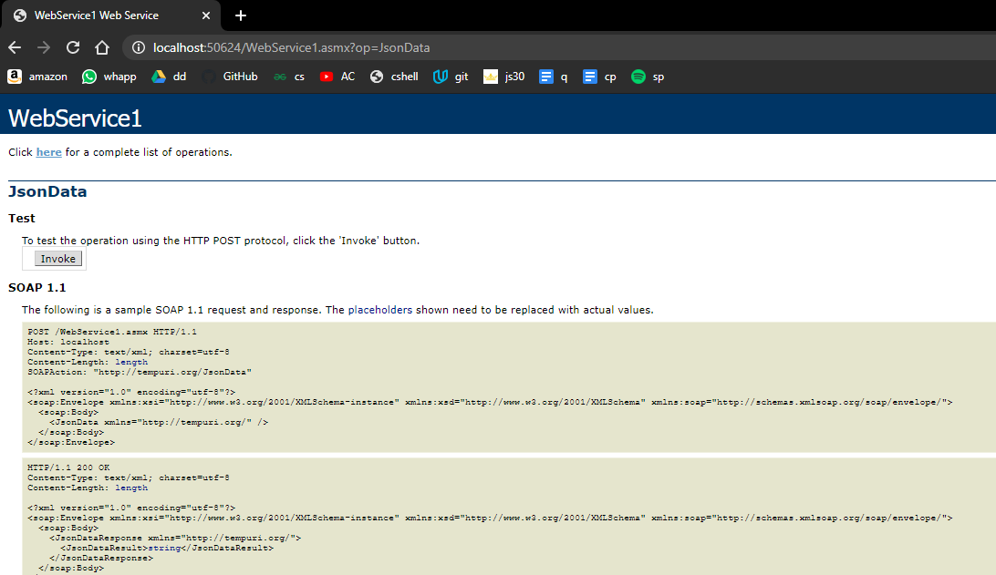

**Now adding Webform in the same solution explorer .**

**(adding newtonsoft.json)**

**Webform1.aspx.cs:**

|  |
| --- |
| <%@ Page Language="C#" AutoEventWireup="true" CodeBehind="WebForm1.aspx.cs" Inherits="prac7.WebForm1" %>  <!DOCTYPE html>  <html xmlns="http://www.w3.org/1999/xhtml">  <head runat="server">  <title></title>  </head>  <body>  <form id="form1" runat="server">  <div>  <asp:GridView runat="server" ID="GridView"  OnSelectedIndexChanged="GridView_SelectedIndexChanged"></asp:GridView>  </div>  <h3>Performed By krunal, 713</h3>  </form>  </body>  </html> |

Webform.aspx:

|  |
| --- |
| <%@ Page Language="C#" AutoEventWireup="true" CodeBehind="WebForm1.aspx.cs" Inherits="prac7.WebForm1" %>  <!DOCTYPE html>  <html xmlns="http://www.w3.org/1999/xhtml">  <head runat="server">  <title></title>  </head>  <body>  <form id="form1" runat="server">  <div>  <asp:GridView runat="server" ID="GridView"  OnSelectedIndexChanged="GridView_SelectedIndexChanged"></asp:GridView>  </div>  <h3>Performed By krunal, 713</h3>  </form>  </body>  </html> |

**Output:-**

